Assignment 2: Tableau Analysis

Name: Gopi Krishna Reddy Katkuri

This assignment adopt the sample Adventure Works Data Warehouse, connecting the tables FactResellerSales, DimCurrency, DimEmployee, DimProduct, DimPromotion, DimSeller, DimSalesTerritory.
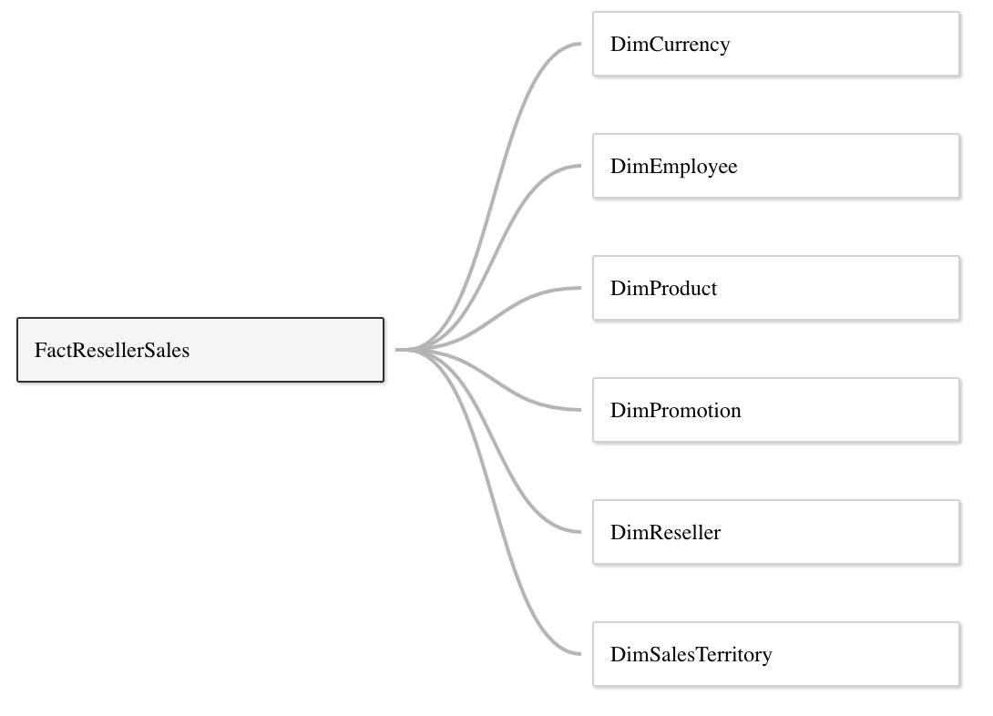

1. Cross Table Calculation and Aggregation:
(1). Create and display a cross table with “Business Type” firstly (from DimReseller) and “Sales Territory Region” secondly (from DimSalesTerritory) as rows, with Year of “Order Date” and Quarter of “Order Date” (discrete types) from FactResellerSales as columns; The value of the cells in this cross table is the average of “Sales Amount” from FactResellerSales;
Besides the values in the cells, generate and display row grand totals, column grand totals and all subtotals in the same cross table;
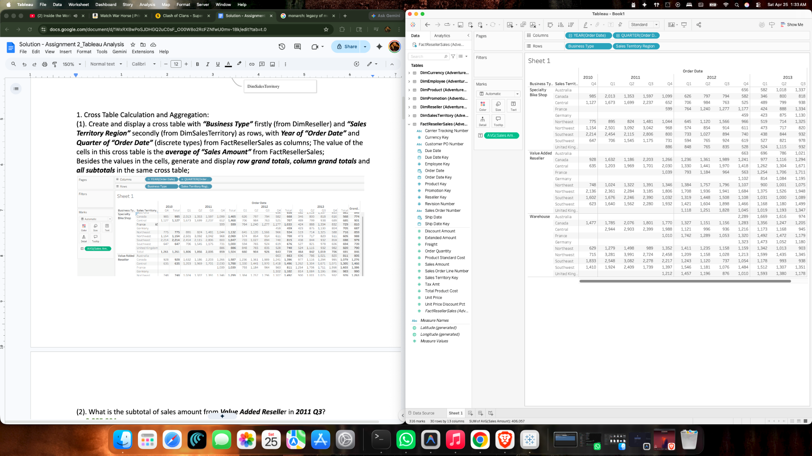

(2). What is the subtotal of sales amount from Value Added Reseller in 2011 Q3?
Ans : 2,285,904
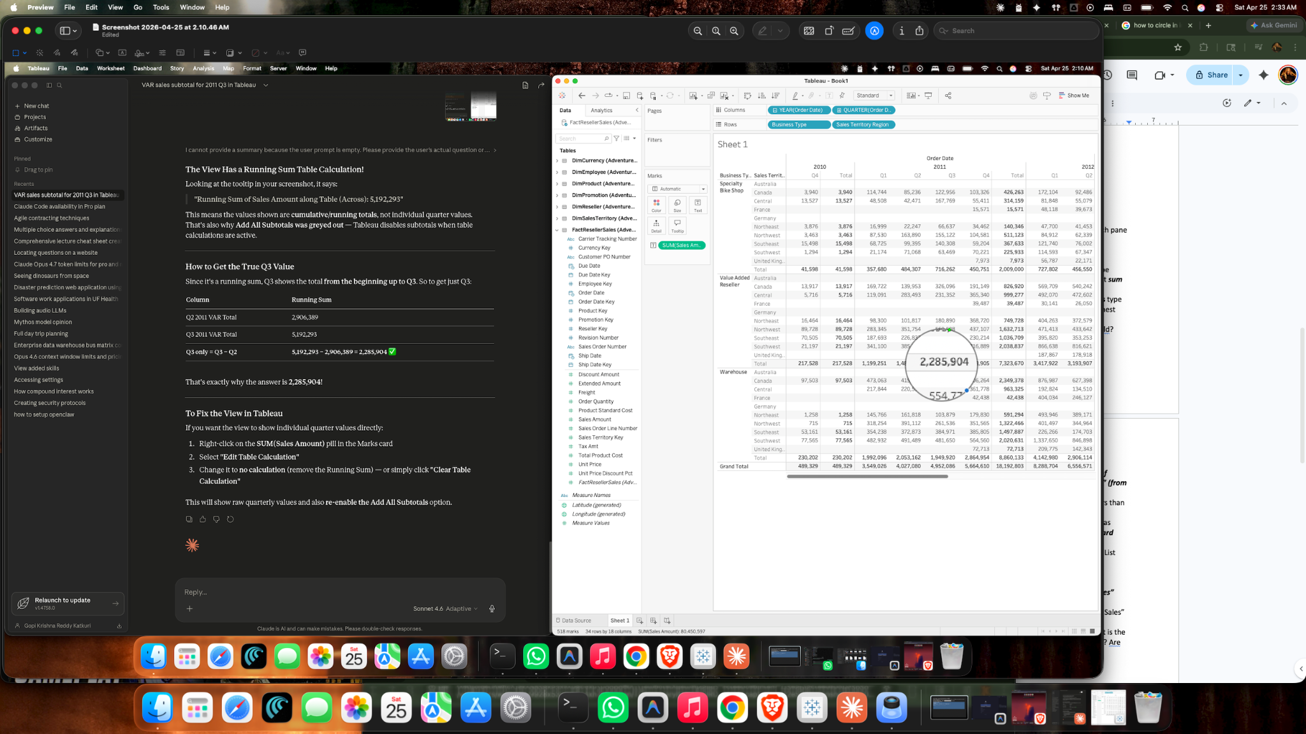
(3). Based on the prior cross table, generate and display quick table calculation with percentage of total, using pane (down);
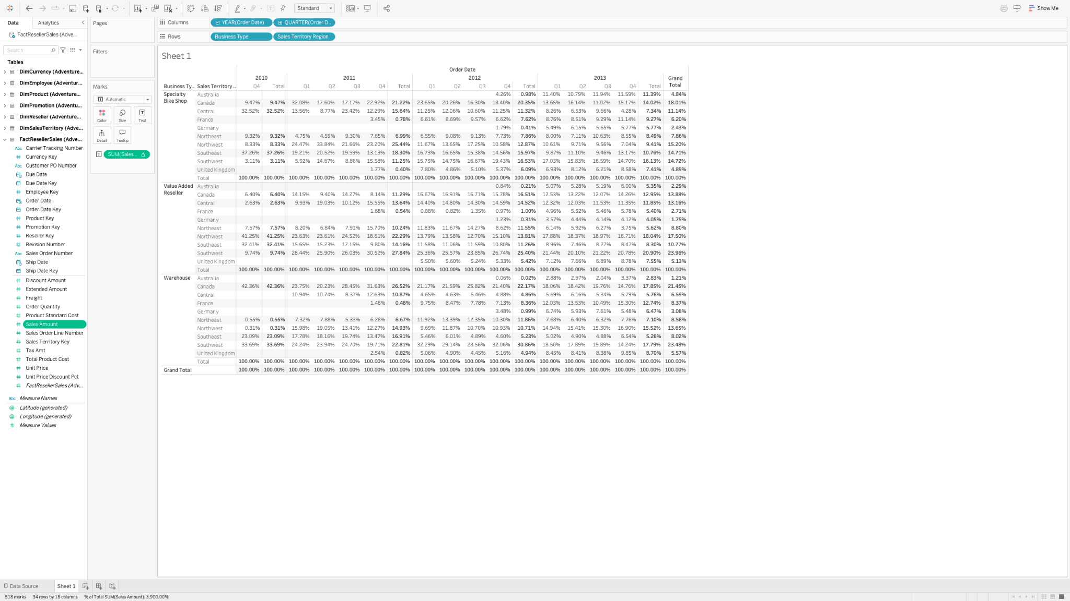
(4). Based on the cross table from (3), Why do we have 100% as the subtotal value at each pane level?
Ans: Tableau is calculating Percent of Total separately inside each pane.
So for a subtotal, it compares that pane’s subtotal to that pane’s own total, which becomes 100%.
That is why every pane subtotal shows 100%—it is the full total for that section, not for the entire table.
2. Discrete and Continuous Date Fields:
(1). Create and display a bar chart, with sum of “Sales amount” as rows, and discrete type month of “Order Date” from FactResellerSales table. Which month overall has the lowest sum of sales amount?
Ans: June
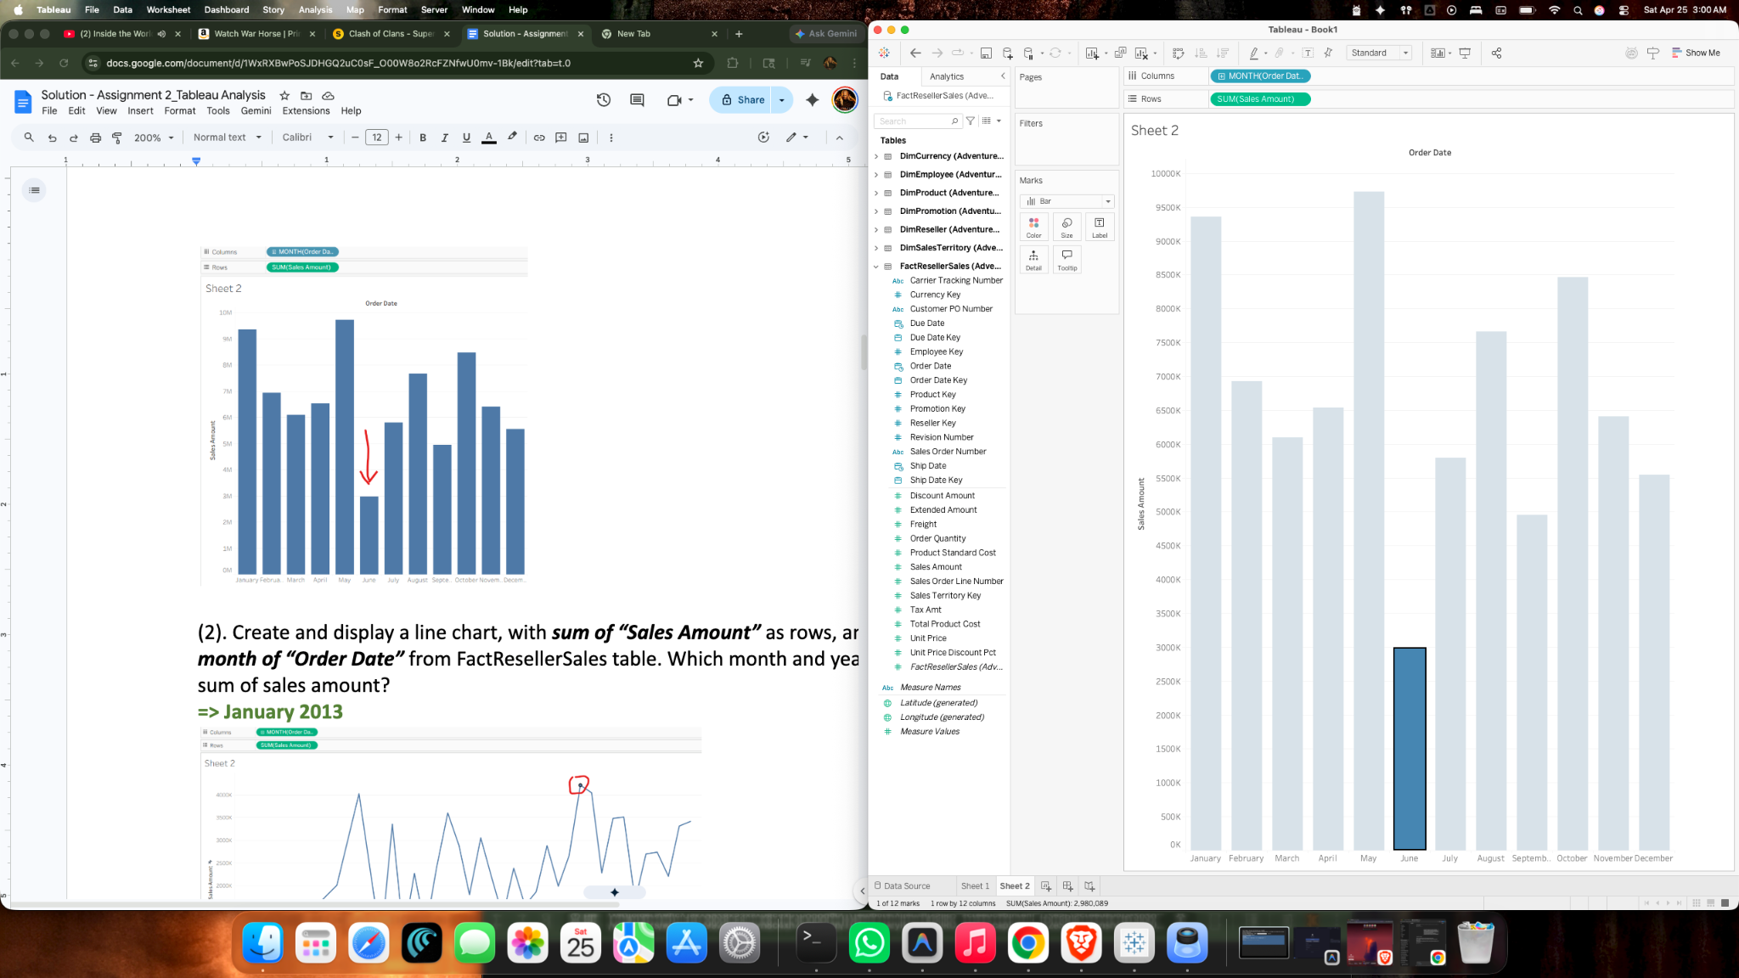
(2). Create and display a line chart, with sum of “Sales Amount” as rows, and continuous type month of “Order Date” from FactResellerSales table. Which month and year has the highest sum of sales amount?
Ans: highest sum of sales amount is in Jan 2013 as below
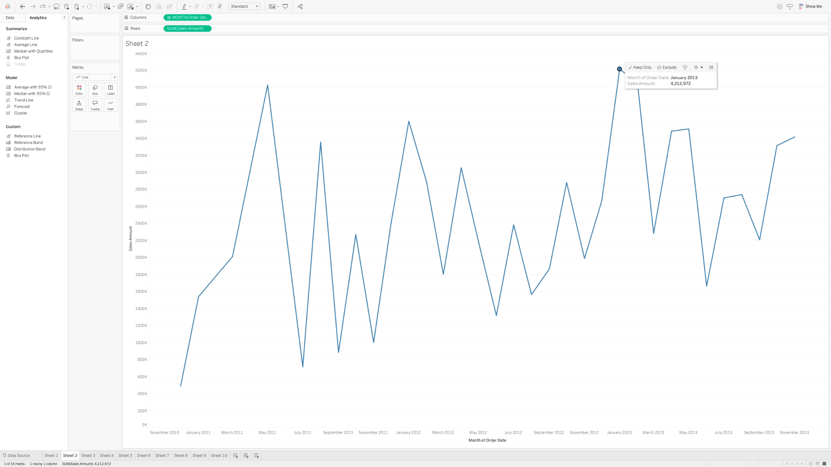
(3). When do we usually use continuous date field, and when do we use discrete date field?
Ans:
- We can use a continuous date Field when we want a timeline or trend over time with a continuous axis.
- We can use a discrete date Field when we want to split data into separate date categories like month, quarter, or year.

3. Dual axis and Combined axis chart:
(1). Compare the average of “Sick Leave Hours” (from DimEmployee) and the average of “Vacation Hours” (from DimEmployee) using a dual axis chart, with “Department Name” (from DimEmployee) as columns; synchronize the two axis and display the chart;
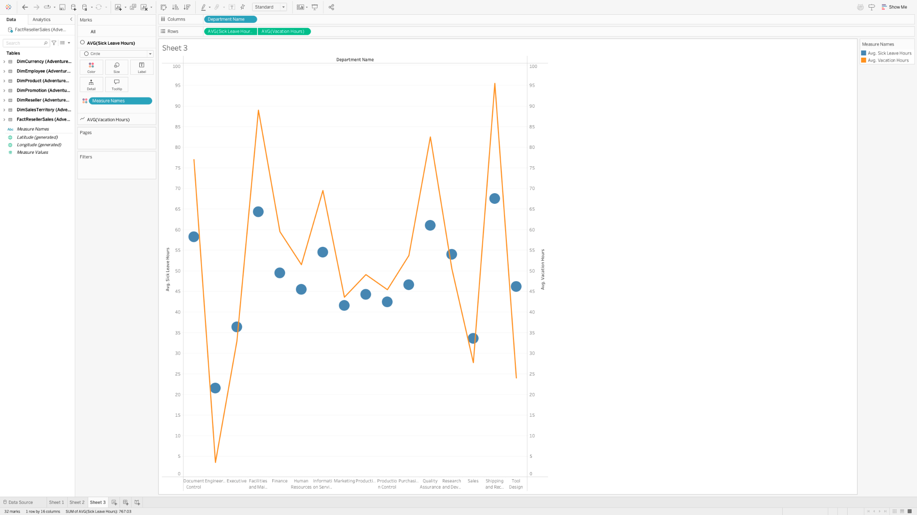
(2). Based on the dual axis chart, which departments have higher average sick leave hours than average vacation hours?
Ans: Engineering, Executive ,Research and development, sales and Tools Design departments have higher average sick leave hours than average vacation hours.
(3). Generate and display a combined axis chart, with “Product Line” (from DimProduct) as columns, and average of “Dealer Price”, average of “List Price”, and average of “Standard Cost” (all from DimProduct) as rows;
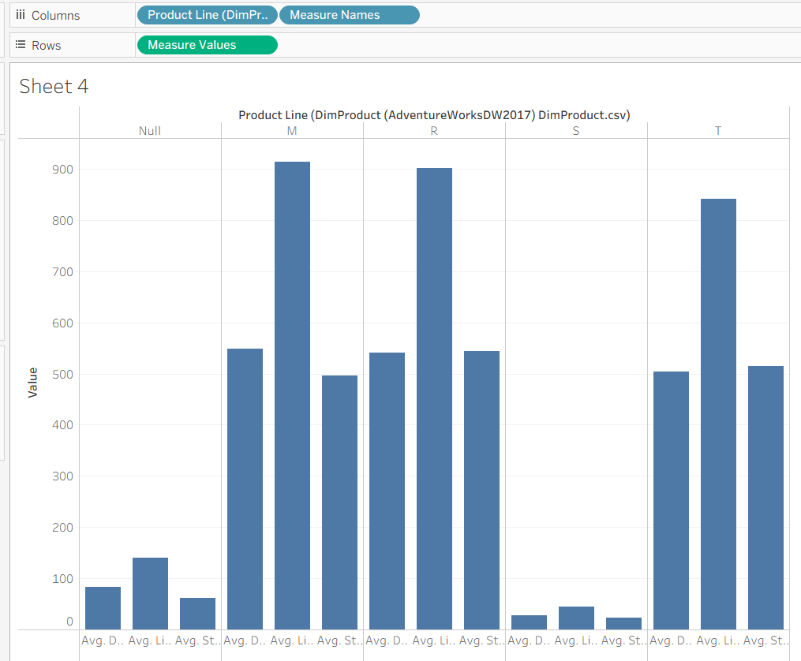

(4). Based on the prior combined axis chart, which product line has the highest average “List Price” and which product line has the lowest average “List Price”?
Ans:
- “M” product line with highest average list price
- “S” product line with lowest average list price
4. Analyze the correlation coefficient between two facts:
(1). Generate and display a scatter plot with facts “Annual Sales” and “Number Employees” from DimReseller; (hint: uncheck the aggregated measures)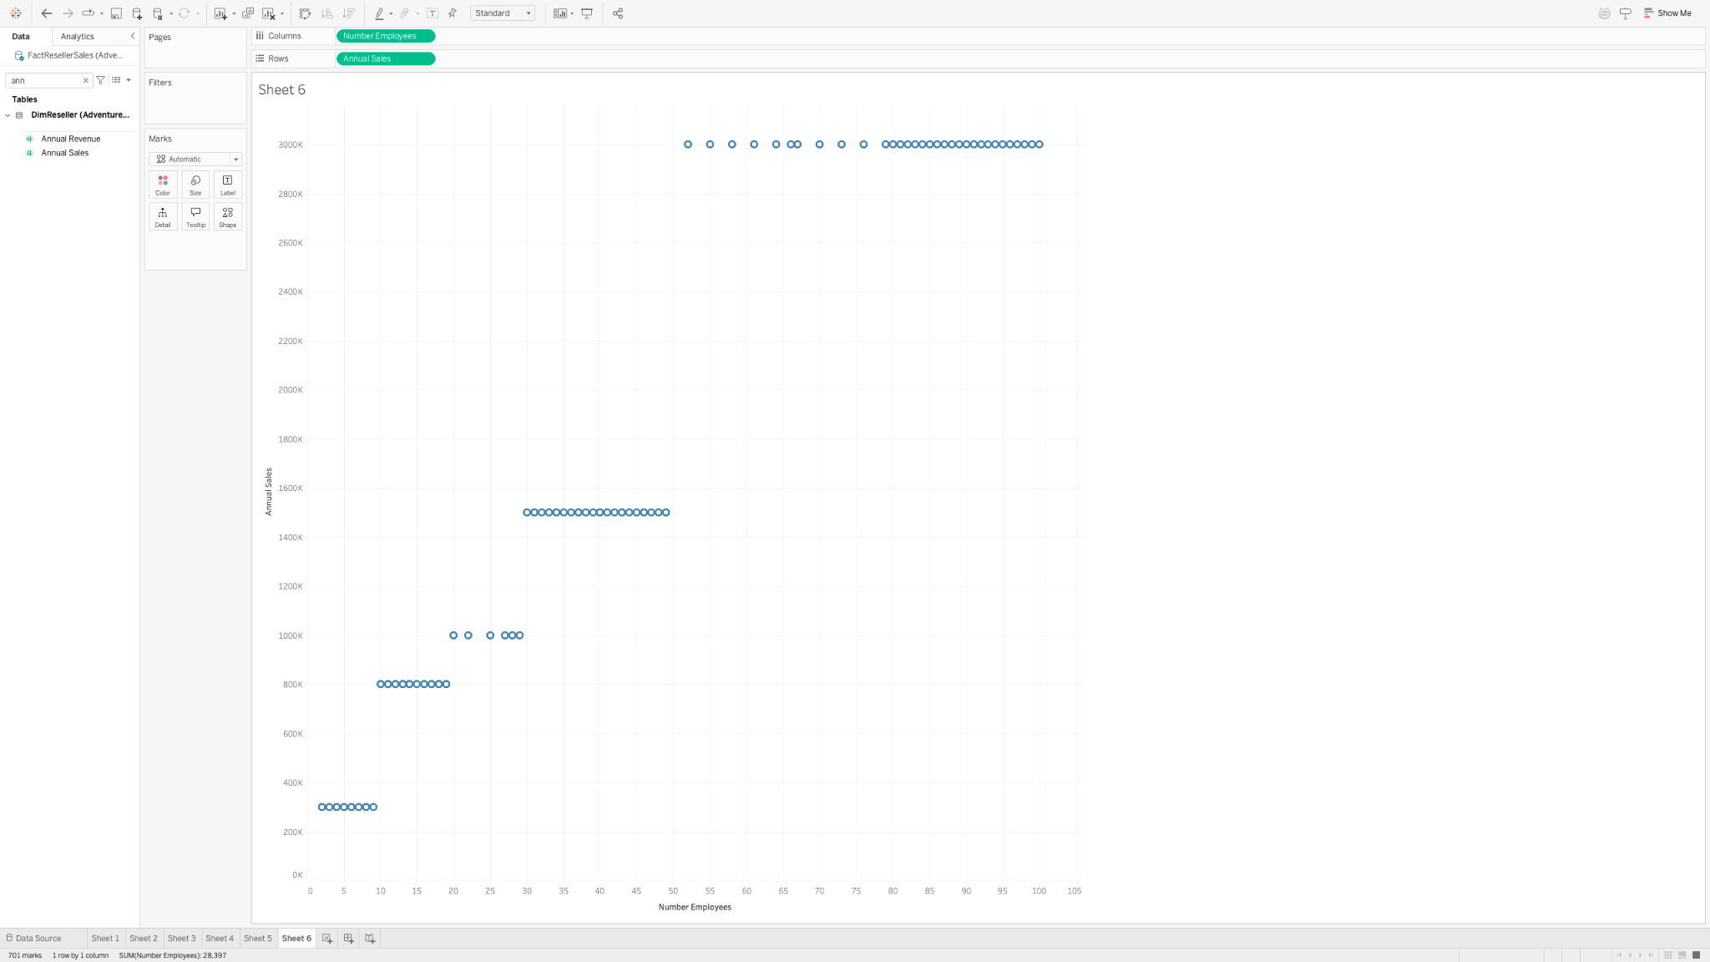
(2). Generate and display a linear trend line on top of the scatter plot with facts “Annual Sales” and “Number Employees”, enable the confidence interval of the linear line.
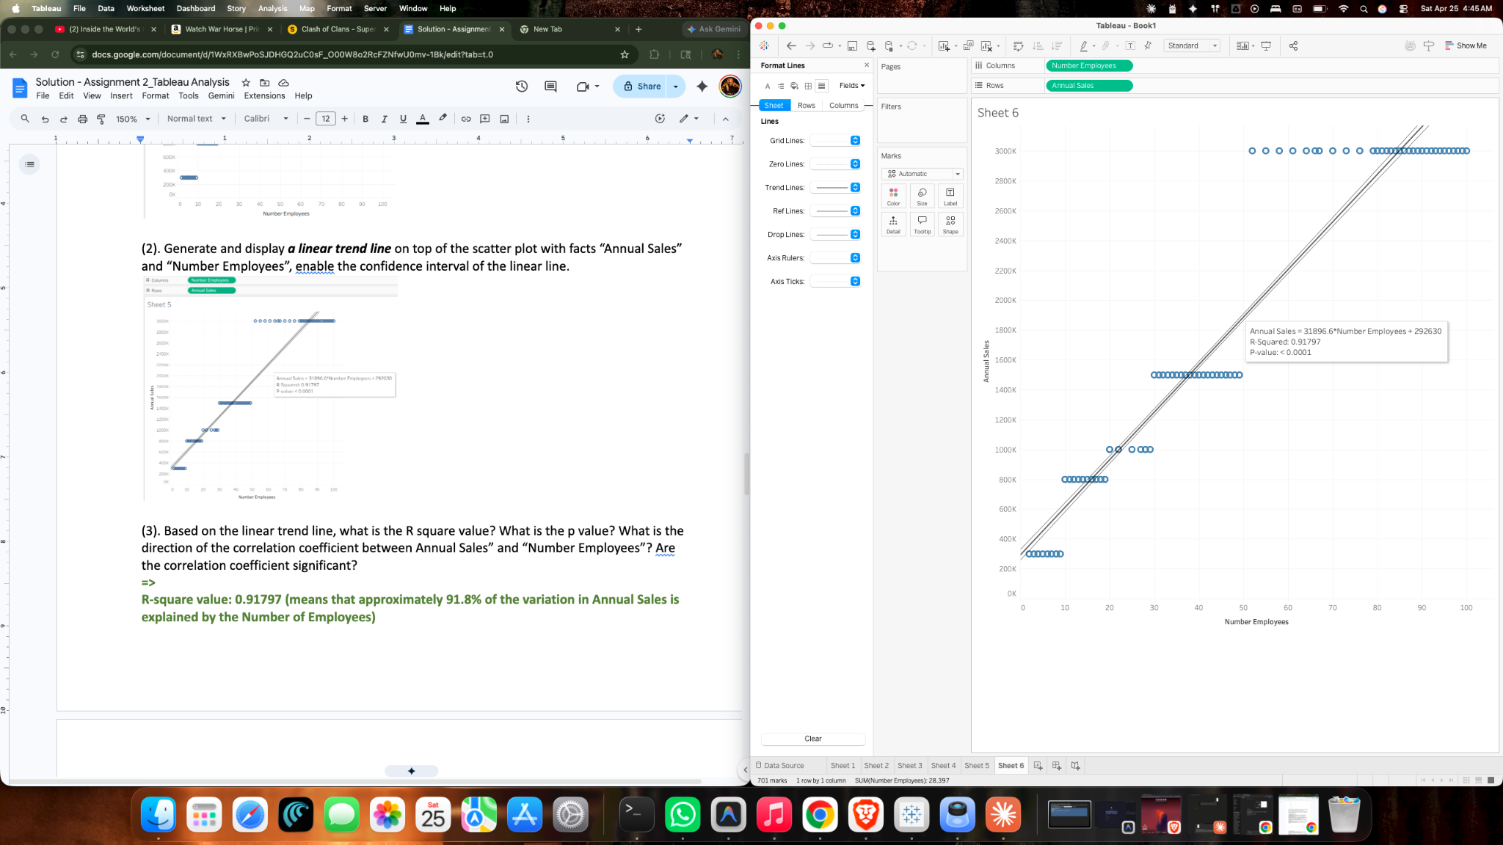
(3). Based on the linear trend line, what is the R square value? What is the p value? What is the direction of the correlation coefficient between Annual Sales” and “Number Employees”? Are the correlation coefficient significant?
Ans:
- The R² value is 0.91797, and the p-value is less than 0.0001.
- The relationship between Annual Sales and Number Employees is positive, since sales increase as the number of employees increases.
- Yes, the correlation is statistically significant because the p-value is much smaller than 0.05.

5. Create Calculated Fields:
(1). Create and display calculated fields:
a. Profit Margin = ((Unit Price – Product Standard Cost)*Order Quantity)/Sales Amount;
b. Total Average Profit Margin = Average ((Unit Price – Product Standard Cost)*Order Quantity)/ Average (Sales Amount);
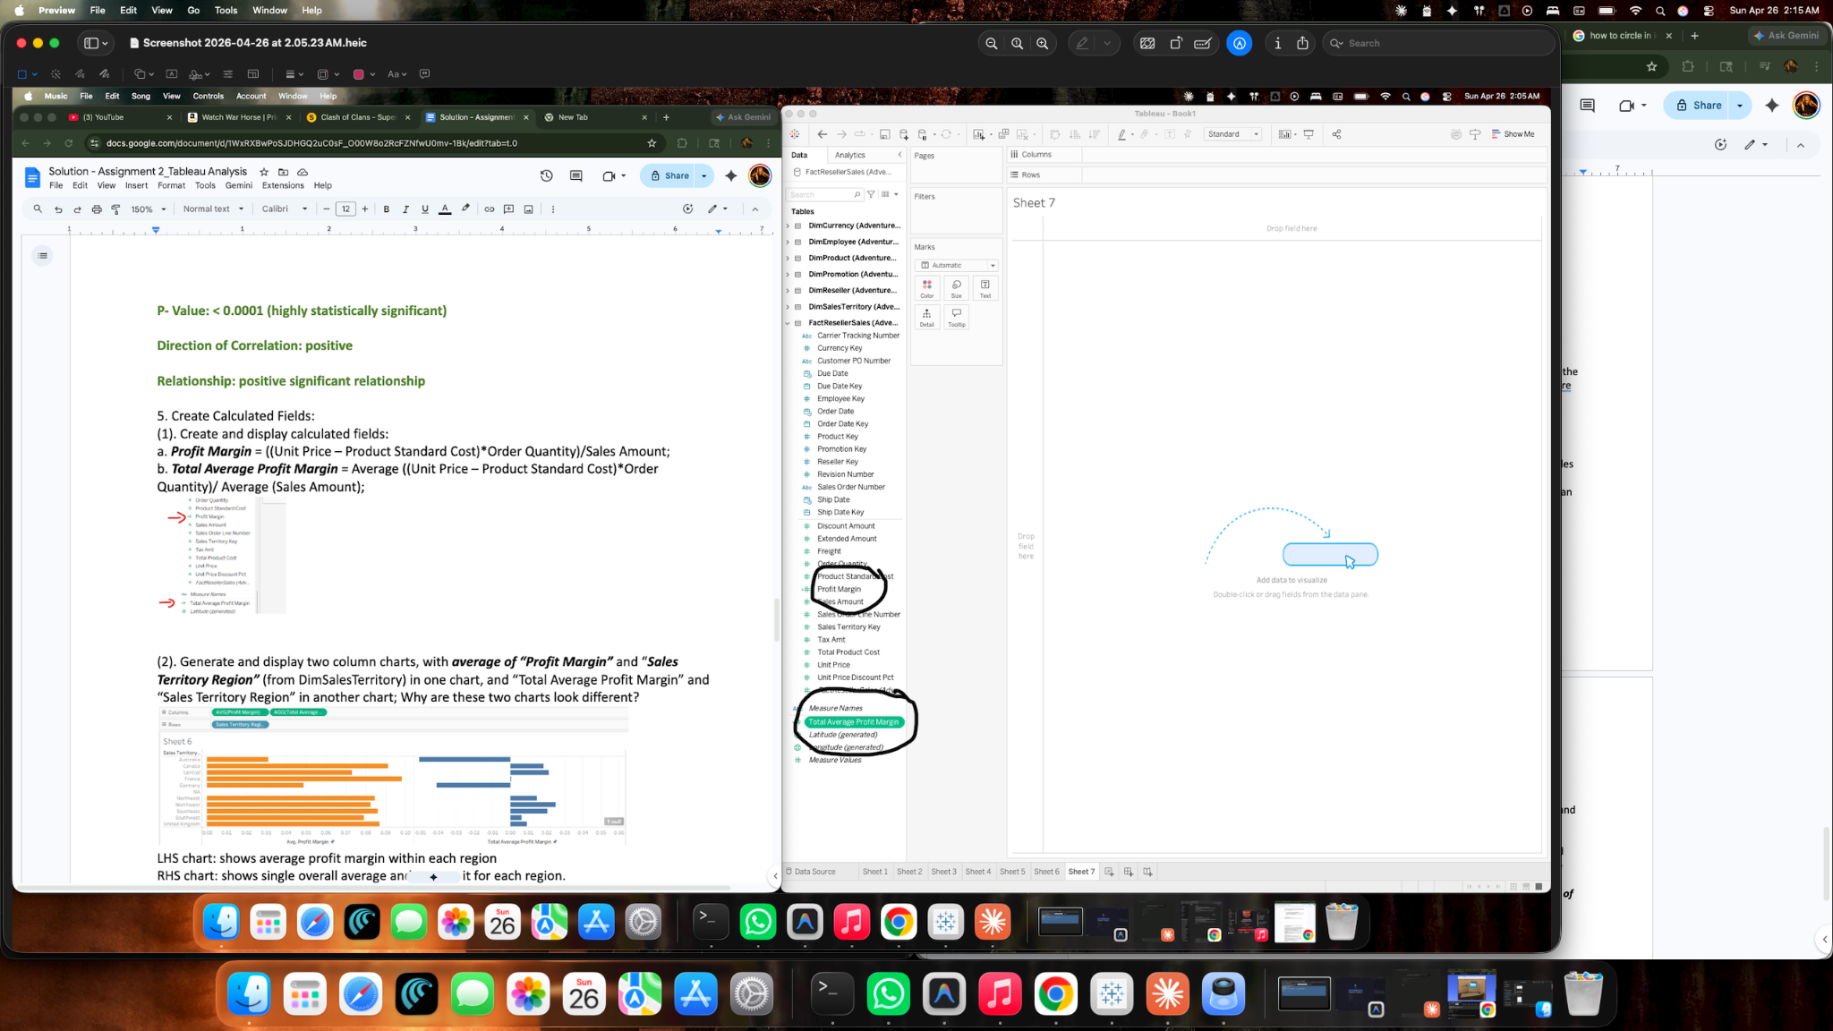
(2). Generate and display two column charts, with average of “Profit Margin” and “Sales Territory Region” (from DimSalesTerritory) in one chart, and “Total Average Profit Margin” and “Sales Territory Region” in another chart; Why are these two charts look different?
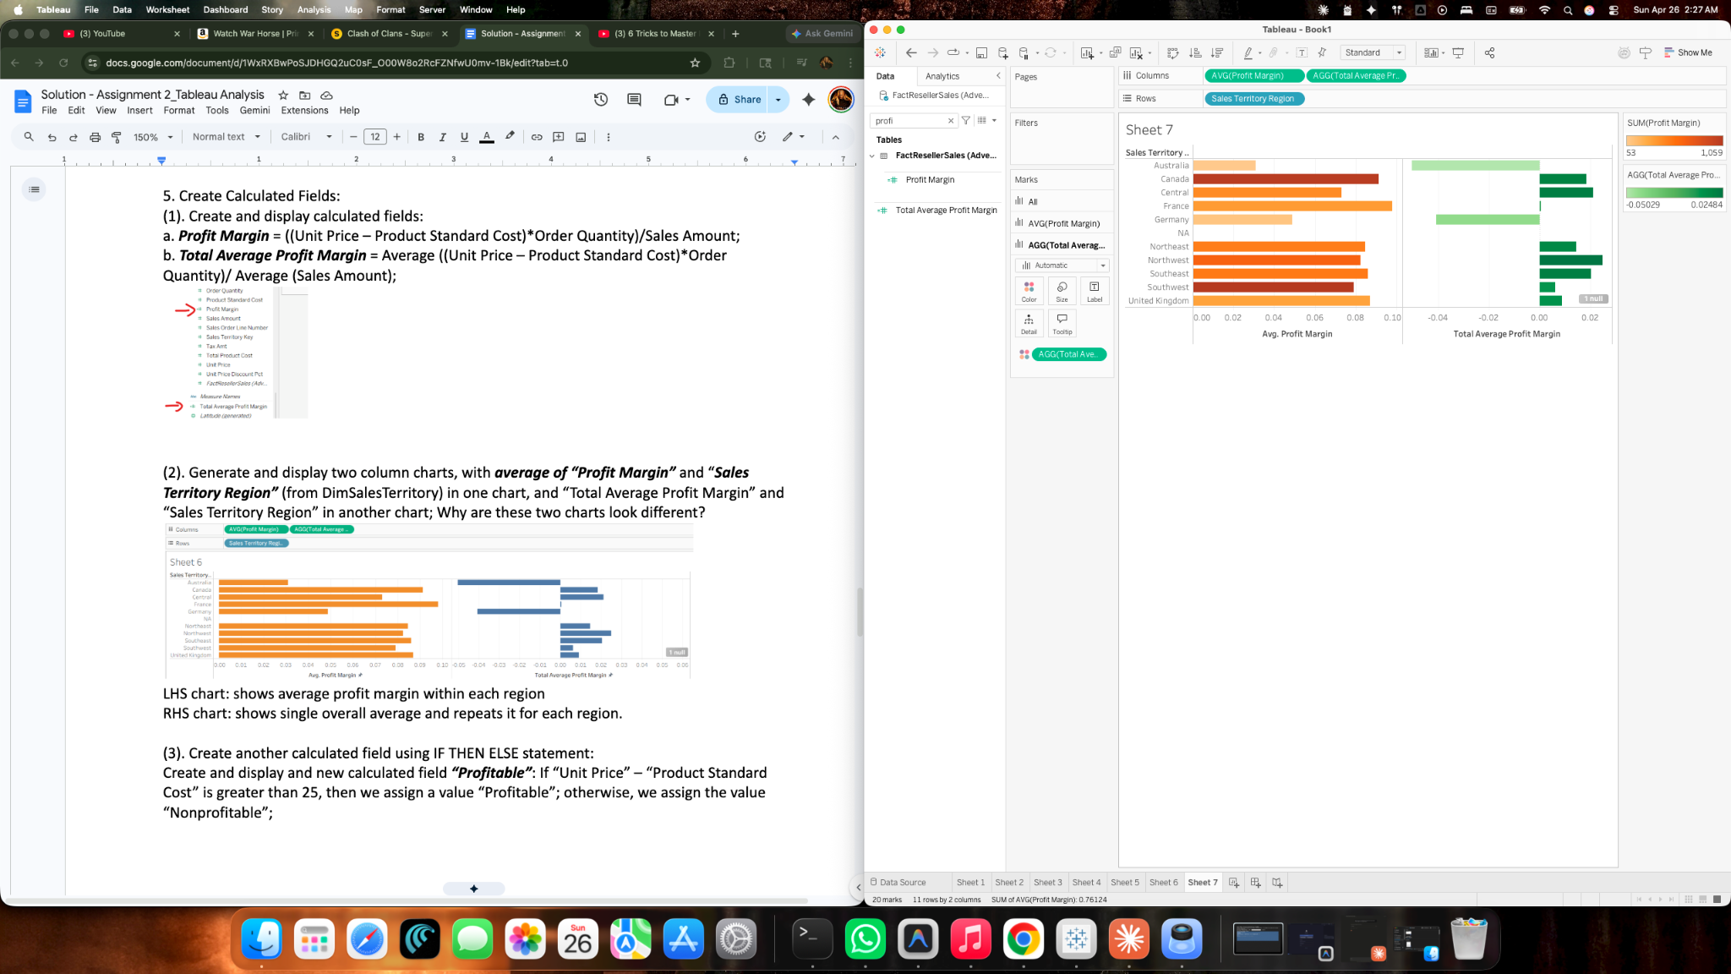
Ans:
- The left side bar chart shows Avg Profit Margin with each Sales Territory Region.
- The right side bart chart shows the Total Average Profit Margin of each Sales Territory Region.
(3). Create another calculated field using IF THEN ELSE statement:
Create and display and new calculated field “Profitable”: If “Unit Price” – “Product Standard Cost” is greater than 25, then we assign a value “Profitable”; otherwise, we assign the value “Nonprofitable”;
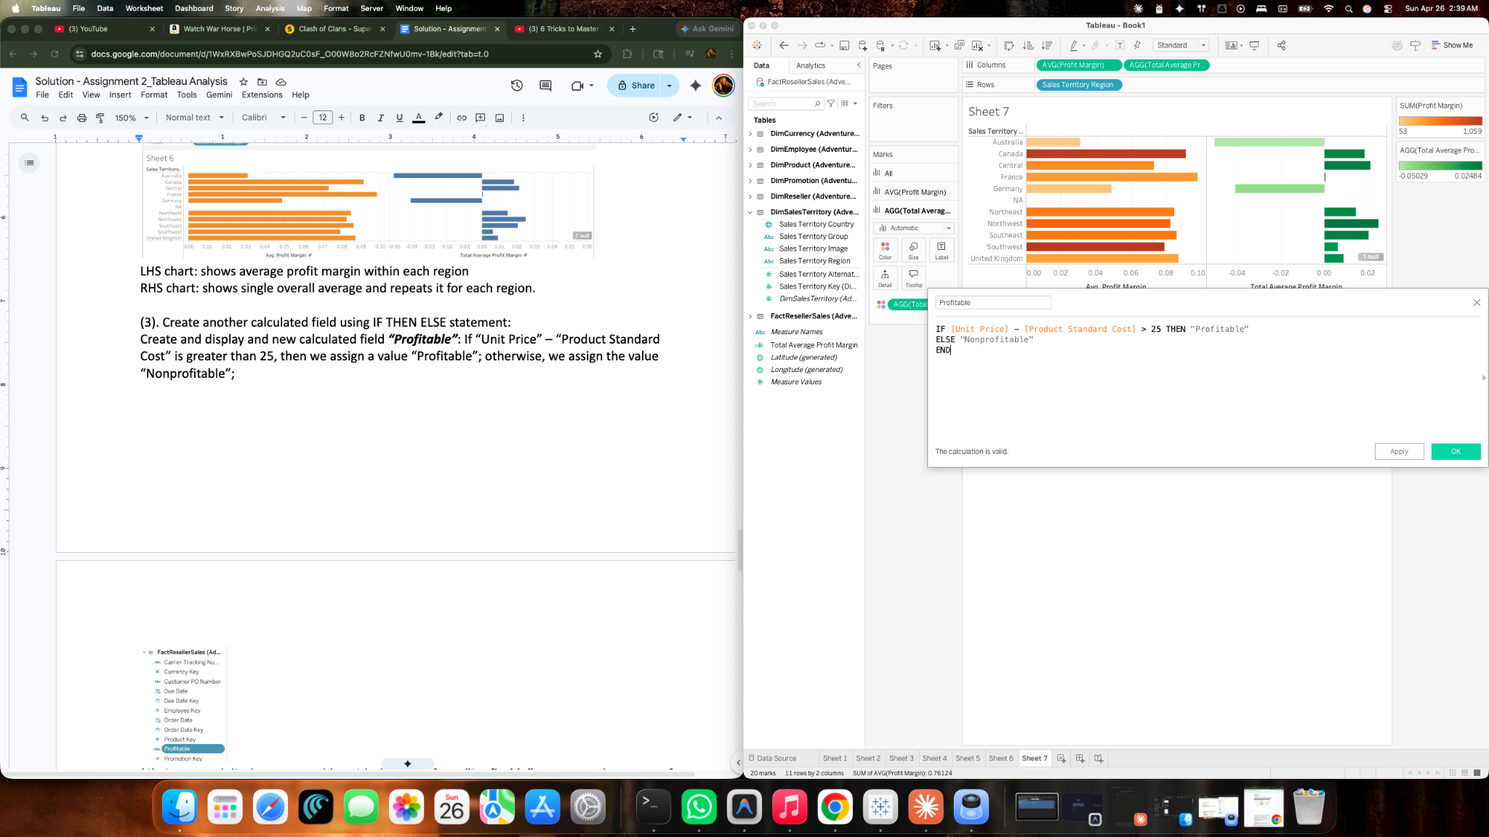
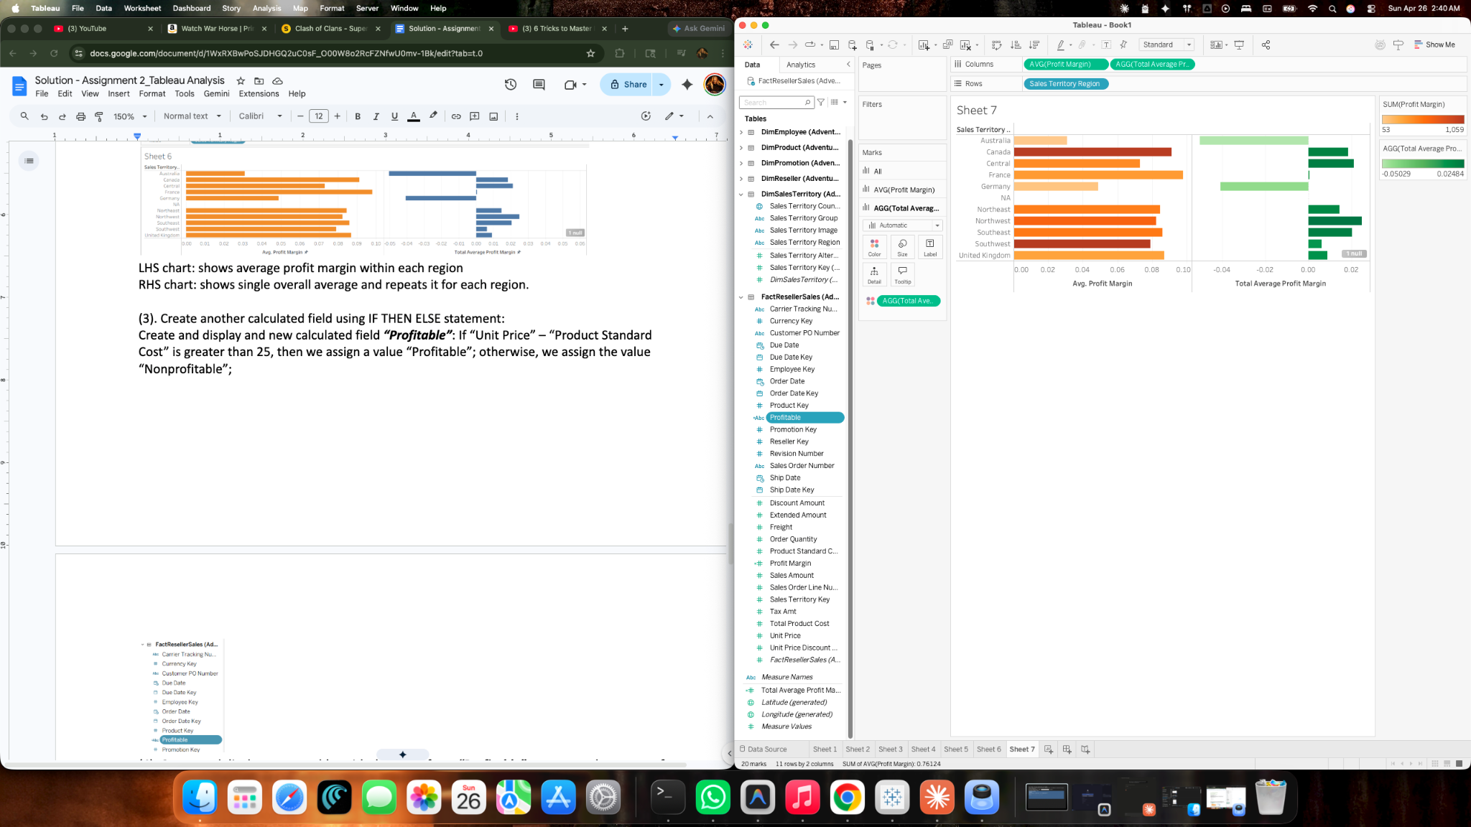
(4). Create and display a cross table, with the levels from “Profitable” as rows, and average of “Profit margin” as cell values in this cross table;
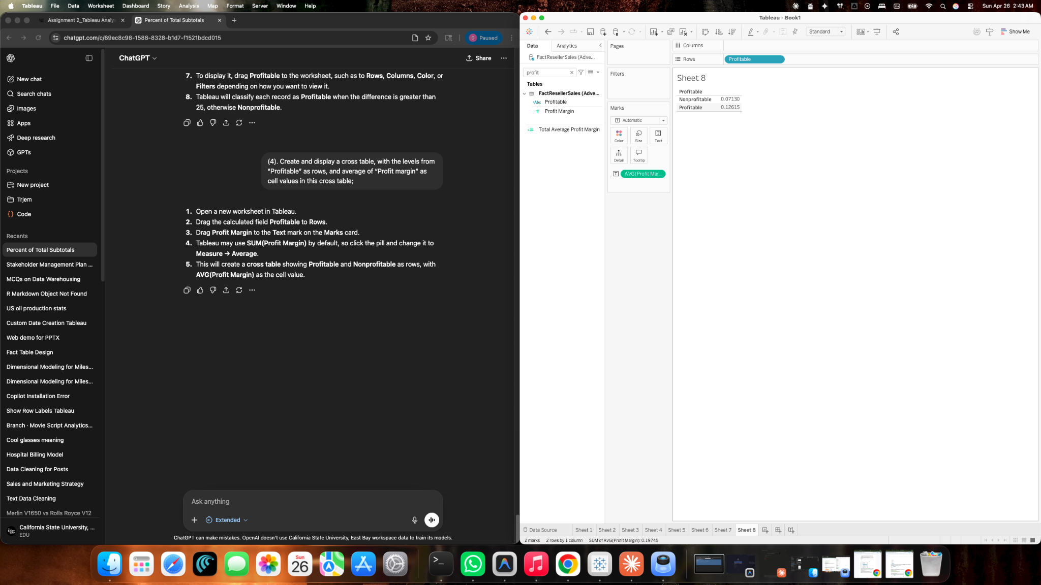
(5). What are the average profit margins for nonprofitable and profitable categories respectively?
Ans:
- Average profit margin of Non profitable is 7.13%
- Average profit margin of profitable is 12.62%
6. Forecasting and Clustering:
(1). Generate and display a forecasting line predicting sum of “Sales Amount” on the basis of month of “Order Date” (continuous) from FactResellerSales table;
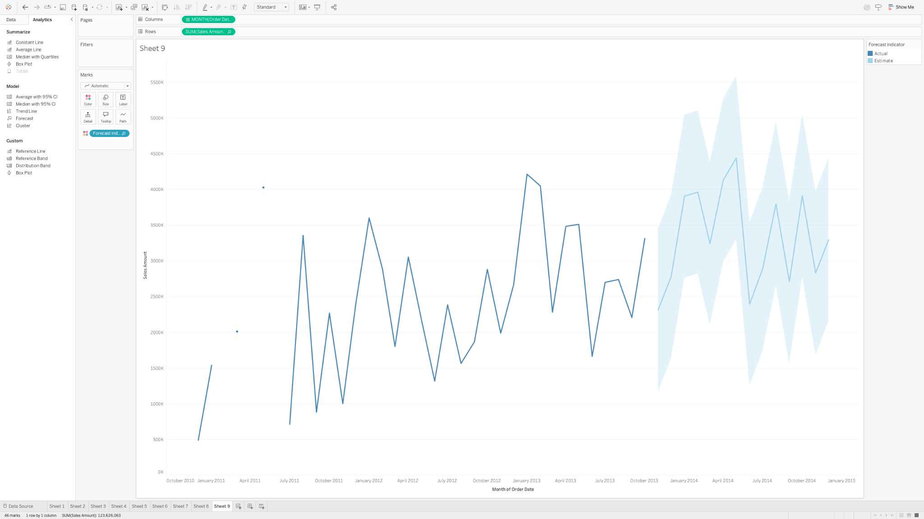
(2). Use default settings from forecast options, how many months’ sum of sales are predicted in the model?
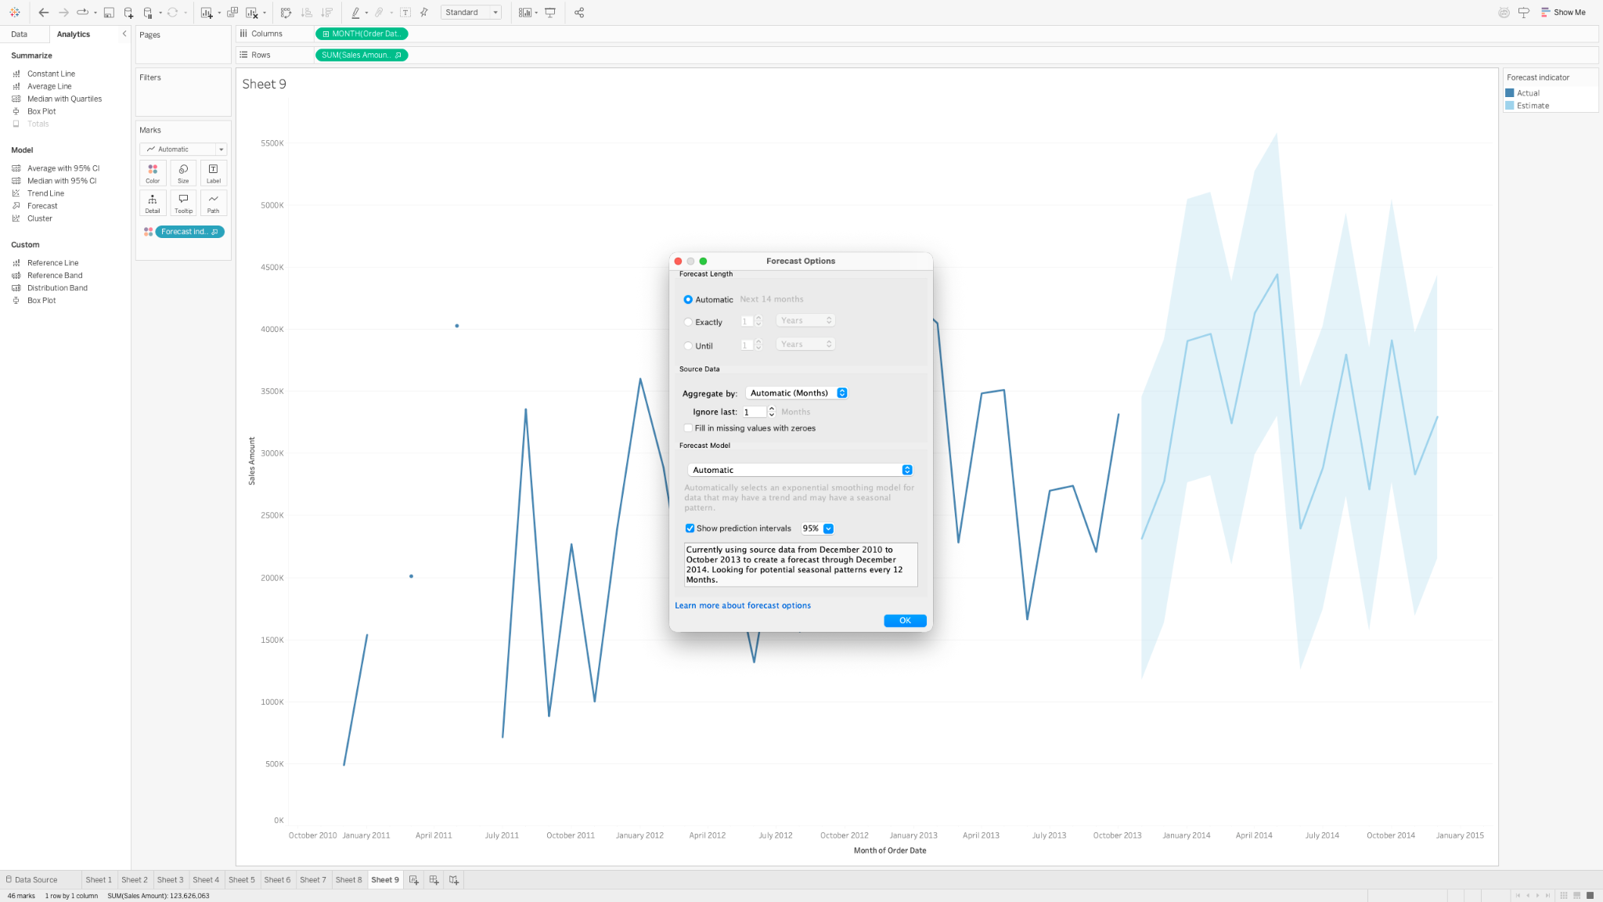
(3). From the summary of the models, what are the quality metrics of the forecasting model?
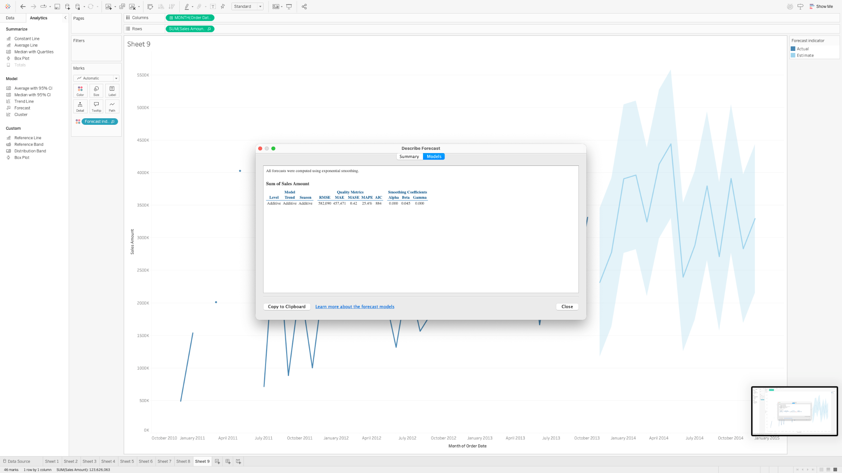
(4). Generate a scatter plot with “Sick Leave Hours” and “Base Rate” from Dimemployee; Cluster the plots in the scatter plot; Display the clusters;
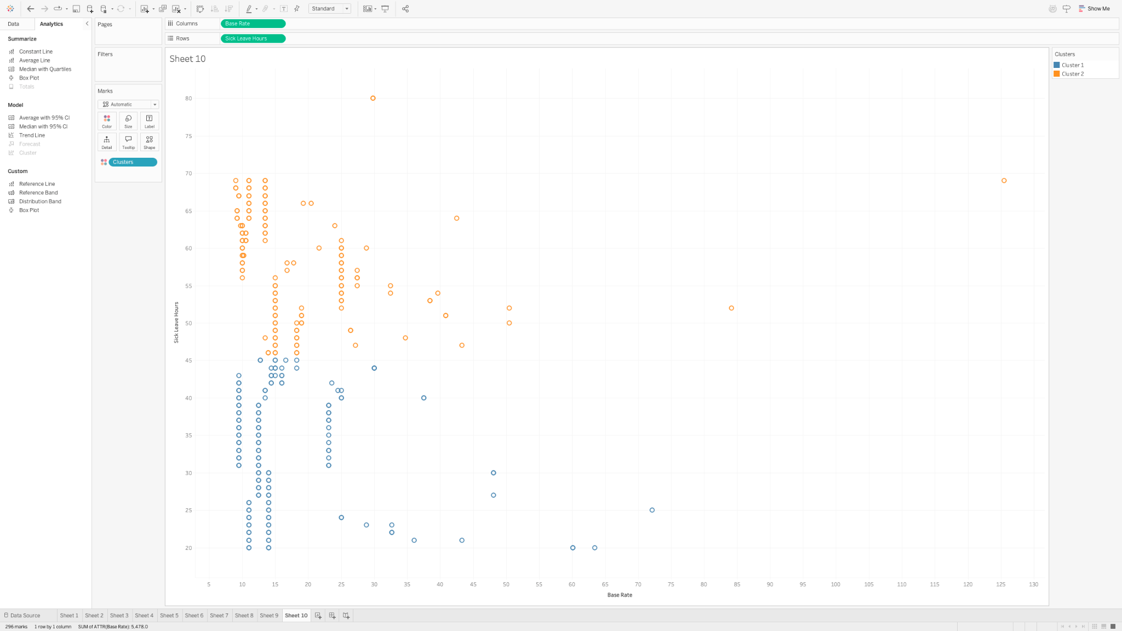
(5). Use the default setting, how many clusters are generated?
Ans: 2 clusters are formed by default.
(6). Change the cluster number to 3, display the clustered scatter plot, how many items are in each cluster?

